**Name: Bodhisatya Ghosh**

**Class: CSE DS**

**UID: 2021700026**

1. **Terminal Commands**
2. *ipconfig*

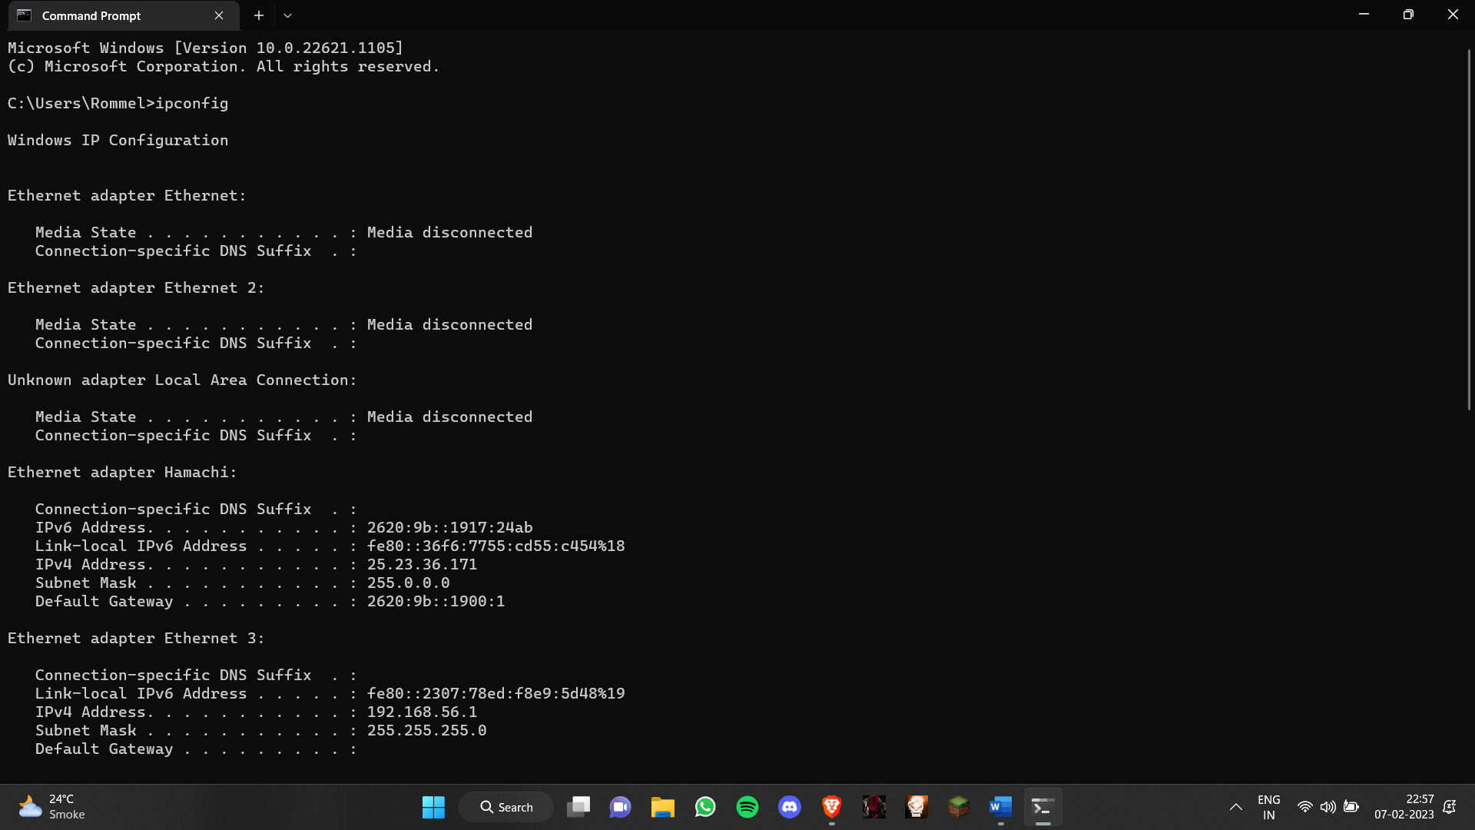

1. *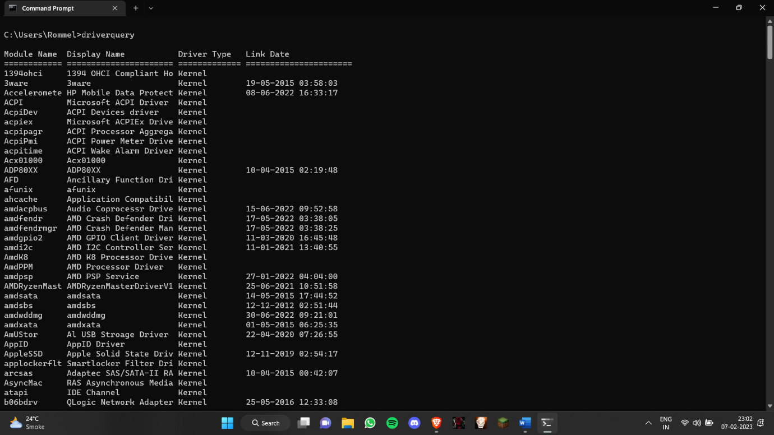driverquery*
2. *for /f "skip=9 tokens=1,2 delims=:" %i in ('netsh wlan show profiles') do @echo %j | findstr -i -v echo | netsh wlan show profiles %j key=clear*

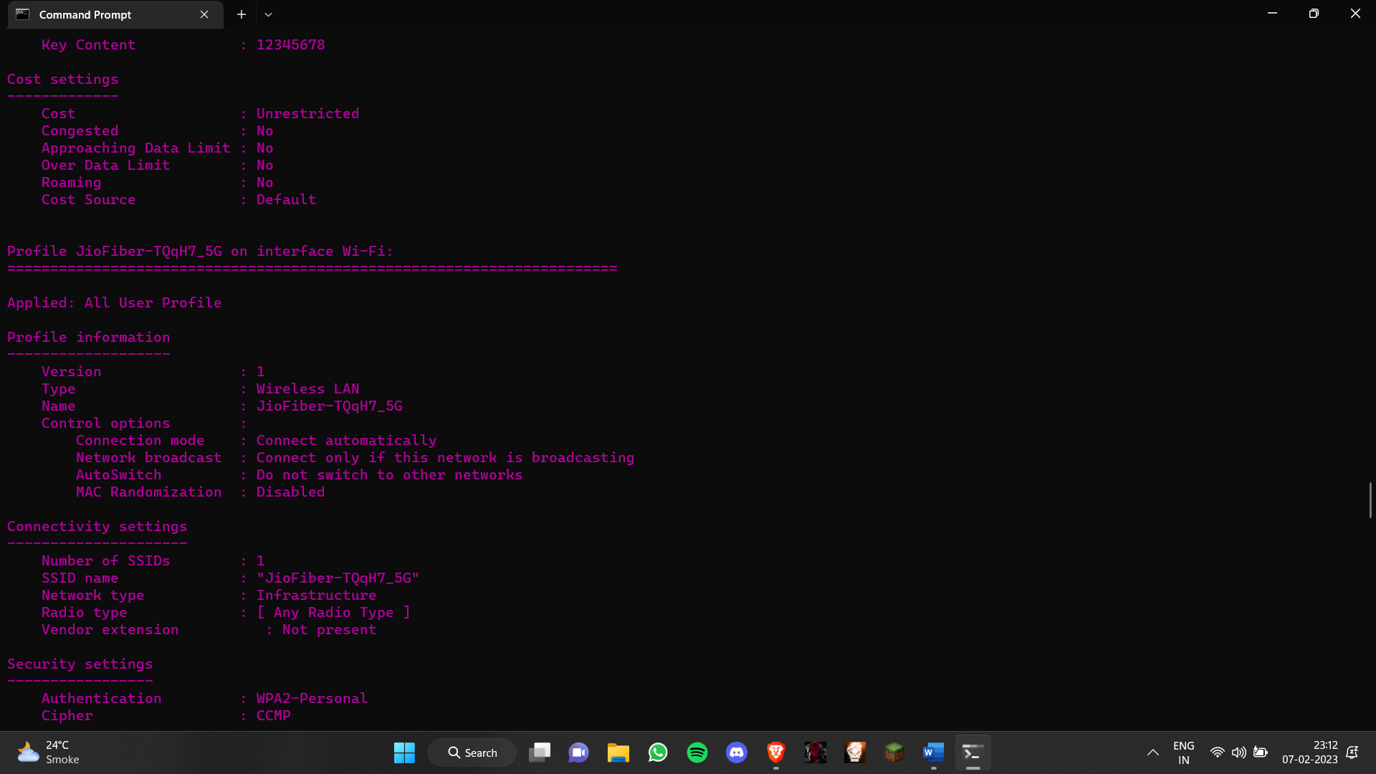

1. *powercfg*

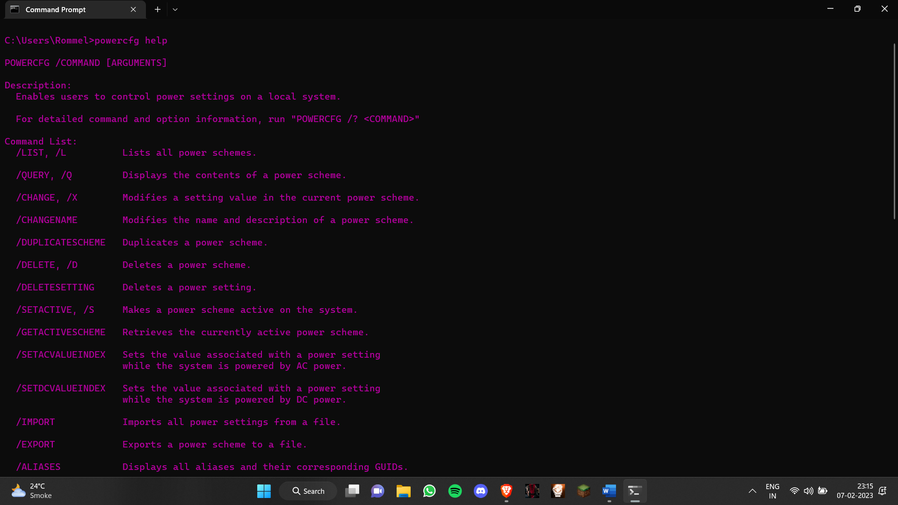

1. *dir*

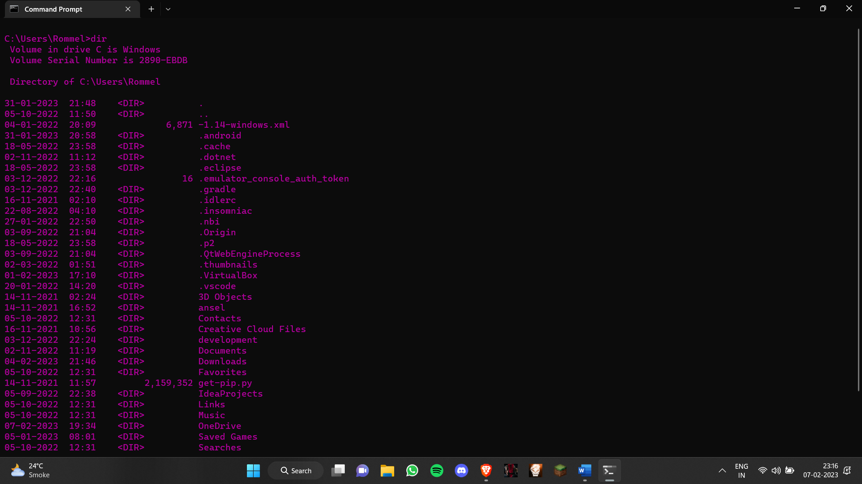

1. ping

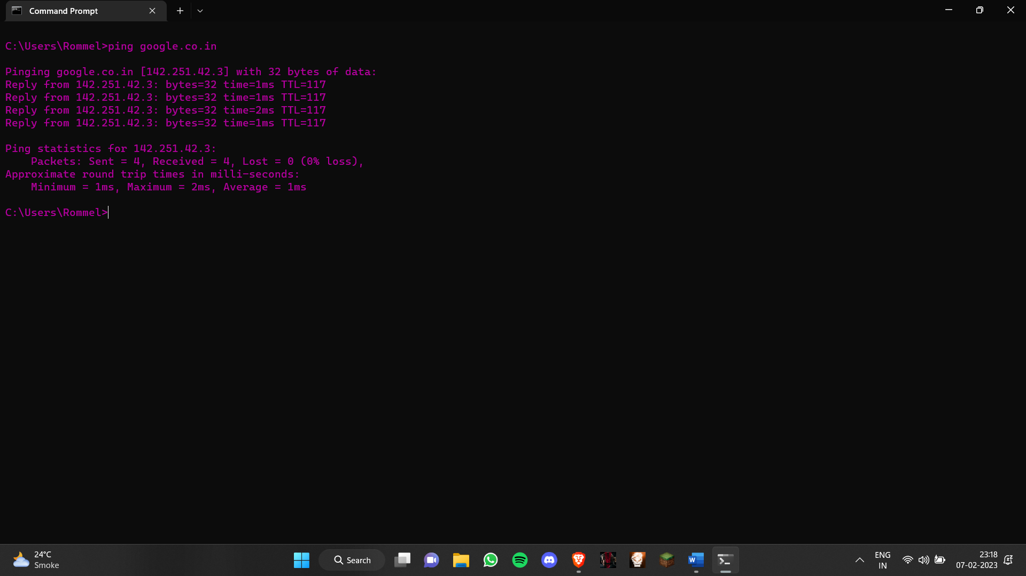

1. netstat

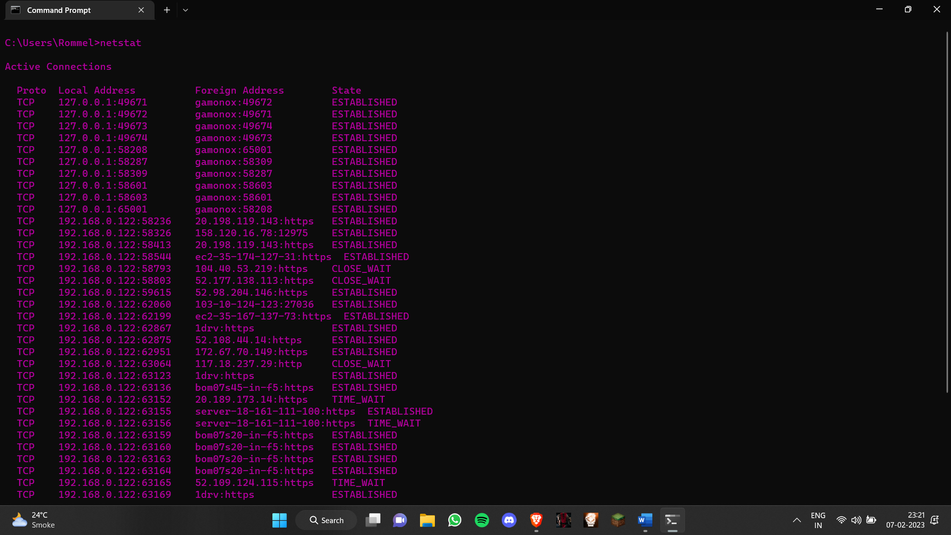

1. nslookup

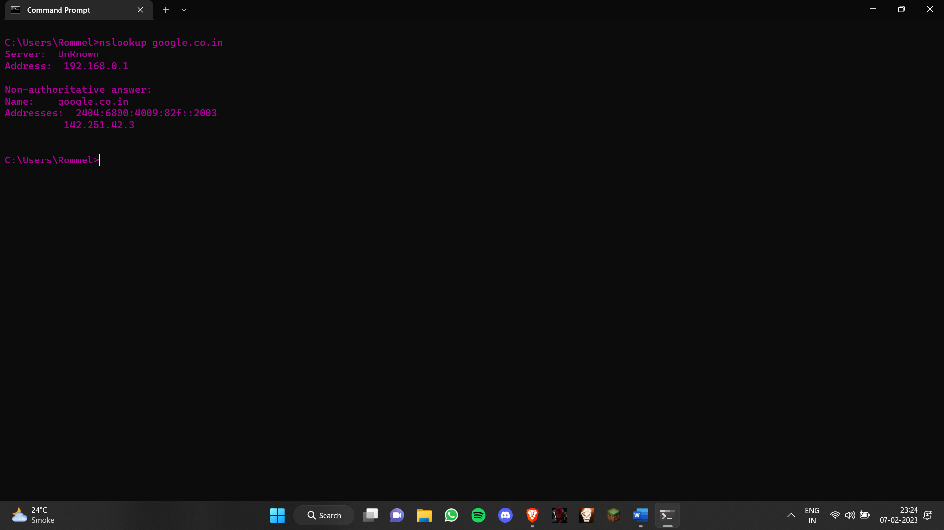

1. tracert

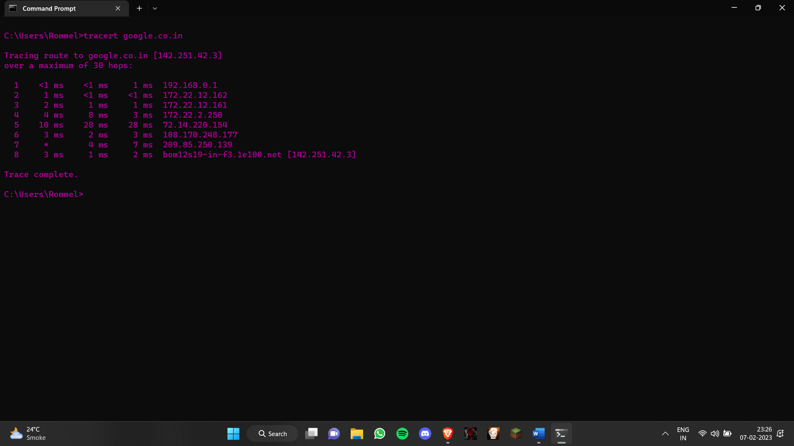

1. arp

